Problem Statement

**1. The Problem**

We often want to share with others not only pictures and sounds from the places we’ve been but also the actual route that we’ve traveled and location cues attached to the pictures and sounds that we record.

**2. Scenario**

In the following section we describe one scenario that the application must support. This scenario must be demonstrated at the final system delivery.

In ornithology lab, Dr. Puffenbarger drives a route through Rockingham County with numerous stops to check out birds so students can learn field identification.  Several students wanted to practice the route on their own, but wanted an electronic map rather than written directions or the poor copy of a physical map Dr. Puffenbarger can provide.  We would like a phone app that allows us to save the weekly routes we run in lab, ideally with pictures, short movies, typed text and links to birds seen at different locations along the route.

**3. Preliminary Analysis**

A preliminary analysis has been preformed resulting in a list of functional and non-functional requirements. Use the scenario above as well as the initial requirements below as a basis for discussions with the client during your analysis phase.

**3.1. Functional Requirements**

* The website allows users to create accounts.
* The app can display a map with the user’s position.
* Users can create *excursions*. An excursion includes a name, a description, a route, and 0 or more *notes*. Routes consist of tuples of GPS data (longitude, latitude & altitude) and date/time stamps. Notes contain time and location information, text data, and possibly images, video and sounds.
* The app can display on a map the route the user has traveled during an excursion.
* A user can set an excursion they created to private or public.
* Users may invite others to view their excursions. The app sends an email or app notification.
* Users may view excursions they are invited to and public excursions. When viewing an excursion, the route is displayed on a map and a list of references to the notes is shown. Each reference to a note is clickable, and when clicked, the app displays the contents of the note.
* Users may *trace* an existing excursion. This functionality creates a new excursion for the user, however no data is copied. The app displays a map with the chosen excursion’s route and the current user’s location and possibly route.
* A user can choose to display or hide notes of another excursion. If the user chooses to display the notes, the notes appear as clickable icons on the map when the user approaches the location where the note was created.

**3.2 Non-Functional Requirements**

* The system is restricted to registered users.
* The application is extensible to deal with additional scenarios.
* Users may download excursions prior to loss of cellular connectivity and use excursion data in the field.
* Data collected by the application about users excursions is persistent and saved in a cloud-based database.
* The system supports relocation of the web site and database.
* The application records excursion information internally without a cellular connection or wireless connection and automatically uploads internally stored data once a cellular or wireless connection is established.
* Model-based software engineering techniques are used in the design of the system. System components are modeled with UML.
* Persistent data must be stored in a MySQL database.
* The application stores and retrieves data from the MySQL database through a web-based application API.
* All software components of this project must be made open-source and include the appropriate open-source licensing agreements.
* The website and application should have the same professional look and feel and utilize the same application terminology and graphics.

**5. Client Acceptance Criteria**

During the requirements analysis phase of the project, the functional and nonfunctional requirements of an acceptable system will be established. The client expects those requirements be fully functional at the time of the final system demonstration tentatively scheduled for 11:00 a.m. on December 3, 2014 in McKinney 345.

**6. Deliverables**

A Requirements Analysis Document (RAD) is due on September 17. An initial prototype of the system is expected six weeks after the functional requirements have been established on October 29.

The client expects a successful demonstration of the system on December 3 with internal and external observers invited to view the demonstration.

A set of documents, posted on the project website, should accompany the demonstration. These documents include the RAD, system design (SDD), object design (ODD), testing procedures (TM), and a user manual of the system.

**7. Top Level Design**

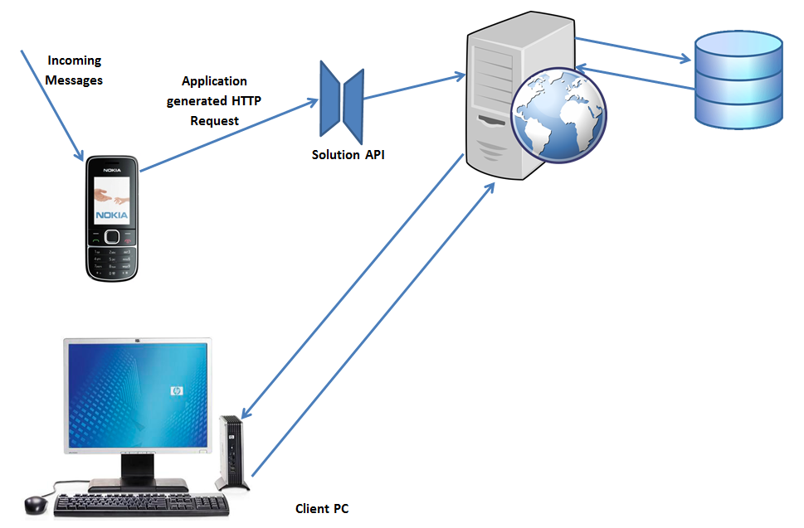

Image from http://stackoverflow.com/questions/16053014/how-to-get-mobile-inbox-message-from-mobile-to-database-using-php.

**8. Operations & Development**

All team members are expected to support the team structure. All communications should go through the appropriate channels. The project leader and client liaison should be the only people to directly contact the clients.

The development and management teams should utilize effective communication systems. They should record meeting minutes for formal meetings and forward them to their immediate supervisor on a timely basis. All team members should plan and record their activities on the appropriate forms and submit them to their supervisors when requested.

It is expected that appropriate software tools be used for development, version control, and bug tracking. The management team will determine the software that is used by the development and management teams.

The application should run on a phone running the Android operating system. The app should authenticate the user and perform other functions that access a MySQL database via an http API.

**9. Team Structure**

Management Team

1. Project Leader: Parker Dell
2. Client Liaison & Planning Manager: Emily Reitz
3. Quality Control Manger: Dylan McGraw
4. App Development Manager: Kyle Siler
5. Web Development Manager: Kristen Kile

Planning Team

1. Emily Reitz (Manager)
2. Samuel Coleman
3. Damian Patterson

Quality Control Team

1. Dylan McGraw (Manager)
2. Brandon Larsen
3. Paul Rachner

Android Development Team

1. Kyle Siler (Manager)
2. Shannon Barrett
3. Tim Miller
4. Katie Estep

Database Development Team

1. Kristen Kile (Manager)
2. Nicholas Hensley
3. Shearl LeVere
4. Michelle Vermaaten
5. Trevor Bostic

**9. Contacts**

Client: Dr. Tim Kreps ([tkreps@bridgewater.edu](mailto:tkreps@bridgewater.edu))

Client: Dr. Robyn Puffenbarger (rpuffenb@bridgewater.edu)

Coach: Dr. Eric McGregor ([rmcgregor@bridgewater.edu](mailto:rmcgregor@bridgewater.edu))

Project Leader: Parker Dell ([dpd003@eagles.bridgewater.edu](mailto:dpd003@eagles.bridgewater.edu))